ASSIGMENT 3.1 TYPES OF HOUSES

Match the types of homes to their definitions. There are two additional types of homes.

a) detached house

b) block of flats

c) cottage

d) semi-detached house

e) farmhouse

f) mansion

g) camper van

h) villa

i) terraced house

1) a luxurious house= f) mansion

2) one of a row of houses that are joined to each other= i) terraced house

3) a van which is adapted for living inside and travelling around= g) camper van

4) a building that consists of many flats= b)block of flats

5) a single house not connected to any other building= a)detached house

6) a house that is joined to one other= d)semi-detached house

7) a small house in the country= c)cottage

1: e) farmhouse

2: h) villa

**Opdracht**

**Describe your house in at least 100 words and add a picture of your house or a similar house.**

Make use of the previous assignments to describe your house. You can use the questions below while describing your house, but use the bullet points only for inspiration! Write a cohesive story (samenhangend verhaal) by using reference words (verwijswoorden) and conjunctions (voegwoorden)!

* Type of house?
* Number of rooms / kind of rooms?
* Your most favourite place at home? Why?
* Special features of your house? Examples: a balcony / garden, etcetera.
* Describe the interior of at least one room (there is/ there are…).

I live in a terraced house with seven rooms; 1 living room(with a tv, tables, chairs and a bench) , 1 kitchen, 1 bathroom, 1 toilet, 1 office and 3 bedrooms. My favourite place at home is my own room, because it is a room where it is nice and quiet and where I can do my own thing. The special features of my house are the two gardens; one in front of the house and one in the back. My house doesn’t have a bacony. In the garden in front of the house we have flowers and in the garden behind the house there are trees and flowers, like two apple trees, a pear tree, strawberry plants, raspberry bushes, sunflowers, a cherry tree, tulips and a palm tree.

Picture of my terraced house:

**ASSIGNMENT 4.1            CITY WORDS VOCABULARY**

**To do the quiz, go to:**[**https://view.genial.ly/60b881dff031cc0db1efb4e3**](https://view.genial.ly/60b881dff031cc0db1efb4e3)

**What words have you learned?**

**I already knew most of the words**

**I leared that in the UK you have a bookshop and in the USA a bookstore**

**ASSIGNMENT 4.2            GIVING DIRECTIONS**

**4.2.1      MATCH EXERCISE**

You know all about your hometown, but what if someone asked you for directions. Would you be able to? After the following exercise you will know for sure!

**Match the words with the pictures**

(from the top down, form left to right)

1: roundabout

2: take the second right

3: next to

4: turn right

5: go past

6: take the second left

7: traffic lights

8: go straight on

9: opposite

10: turn left

**ASSIGNMENT 4.3            HOMETOWN- WRITING**

**Writing assignment: Describe your hometown in at least 100 words.**

What can you say about the place where you live?

Make use of the aspects given below.

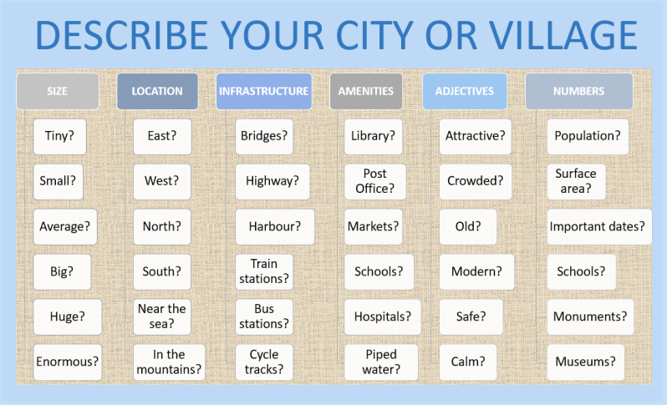

1. What is the name of the place where you live? Zwijndrecht
2. Make sure you describe the following:
   1. Size and numbers of your city.
   2. Location of the place where you live.
   3. Landmarks in your Hometown: churches, library, town hall, well-known pub, town square, park, statue or monument of some kind, mosque, shopping mall, restaurant, big tree, school or university, hill, etcetera.
   4. Things to do in your hometown
   5. Surrounding area in your hometown
   6. Infrastructure in your hometown
   7. Amenities (voorzieningen/ faciliteiten)
   8. Shopping in your hometown
3. Draw a conclusion about your hometown (use adjectives)

